**REVIEW FOR FINAL EXAM (Biology IB)**

1. If DNA separates into two complementary strands, then the DNA is going through ________________________.
2. The instructions for the traits of an organism are coded in ___________________________.
3. 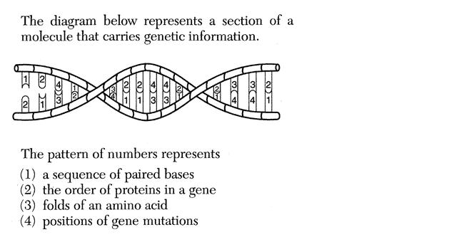If a single-celled organism containing 8 chromosomes goes through reproduction then the offspring will have how many chromosomes?
4. Looking at Figure 1, what do the numbers represent?
5. Compare and contrast “chromosome”, “gene”, and “DNA”

**Figure 1: A random sequence of DNA**

1. Explain the process of protein synthesis beginning with the strands of DNA all the way to the assembly of amino acids into the proteins themselves.

**In your response, include the following terms: codon, anticodon, nitrogenous base, DNA strand, complementary strand, DNA polymerase, transcription, RNA, mRNA, rRNA, tRNA, RNA polymerase, amino acids, ribosomes, proteins**

1. What is DNA replication and how does this process occur? Include the untwisting of the DNA molecule, separations of the DNA strands, pairing up of molecular bases, and the actual copying process which forms the two identical DNA molecules.

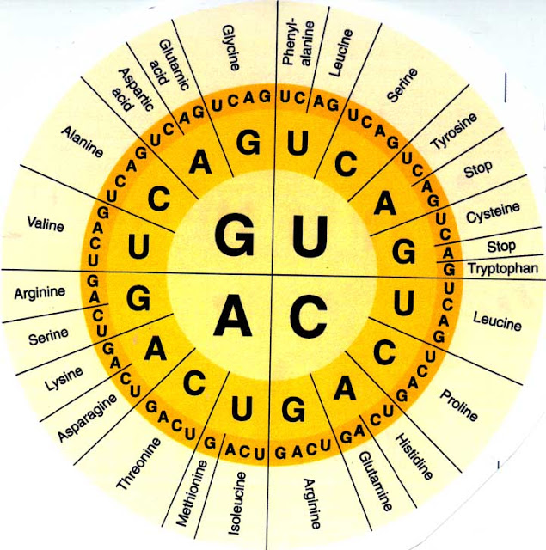

1. Thoroughly describe the relationship between cells, DNA, and proteins.
2. What is the genetic code of a DNA molecules determined by?
3. Using the “wheel” in Figure 2, what chain of amino acids does the following RNA sequence code for?

C – G – G – C – A – G – G – A – G – U – U – U

1. The **DNA** sequence for a particular protein is

AAA-CAG-CTG. What is the corresponding RNA sequence?

1. Using Figure 2, how many amino acids does the sequence in

question number 11 contain? What are these amino acids?

1. Explain Chargoff’s Rules and how this is used in complementary base pairing.

**Figure 2: Codons -- RNA to Amino Acid**

1. If CUA is the codon for Leucine, what is the anticodon for this amino acid?
2. What is a mutation and what might this cause? DO NOT SAY DEATH!, discuss the joining of the amino acids and how this might affect the appearance and other characteristics?
3. What is a diploid genome? _______________________________________________________________________
4. Explain the role of meiosis and fertilization during the reproduction process. How does this ensure the correct number of chromosomes for the offspring?
5. After meiosis in plants, the resulting cells grow into new plants. How are the offspring different from the parents?
6. 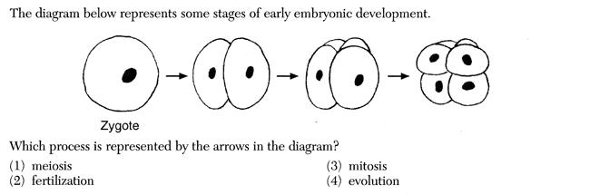What is a sex cell and what may occur if there is a sudden change in the DNA within a sex cell?
7. Figure 3 represent what process? Mitosis or Meiosis? Thoroughly explain what occurs during this process.

**Figure 3: Stages of early embryonic development**

1. Compare and contrast the term “zygote” as seen in Figure 3 with the term “gamete”
2. What do human egg cells have in common with human sperm cells?
3. What do multicellular organisms use mitosis for? What do they use meiosis for?
4. What occurs during each phase of the cell cycle? -- mitosis, cytokinesis, interphase (G1, S, G2) – which part of the cell cycle takes the longest time?
5. How many amino acids does the following sequence code for? 5’ CGCTAGGGGCCTATC 3’ Answer:_______________
6. How would the DNA sequence **C A C T G T C T A A** be coded for in mRNA?
7. Are mutations always bad? What do they increase? How can they be beneficial to a species?
8. What mutation might have little or no physical effect on the organism? Which one might be disasterous?
9. What structure (shape) does DNA have? Draw an example of this in the space provided.
10. What are the monomer units of DNA and RNA? ________________________________.
11. What are the monomer units of proteins? ______________________________________.
12. What are the three parts of a DNA nucleotide? What are the three parts of an RNA nucleotide?
13. ________________________________ 1. ________________________________
14. ________________________________ 2. ________________________________
15. ________________________________ 3. ________________________________
16. What is Down syndrome and how explain how this occurs.
17. Complete the following table (hint: remember Chargoff’s Rules and what you know about base pairing):

Each sample contains 800 total base pairs.

|  |  |  |  |  |
| --- | --- | --- | --- | --- |
| Sample | A  ( __________ ) | T  ( __________ ) | G  ( __________ ) | C  ( __________ ) |
| A | 250 |  |  |  |
| B |  | 300 |  |  |
| C |  |  |  | 175 |
| D |  |  | 225 |  |

1. Which sample contains the least number of T? _____________________
2. Which sample contains the greatest number of C? _____________________
3. Be able to use a dichotomous key! Be able to interpret a cladogram.
4. Study the following vocab terms:

**Chapter 10:**

* Cell cycle
* Spindle
* Homologous chromosomes
* Diploid
* Interphase
* Mitosis
* Cytokinesis
* Gametes
* M phase
* Daughter cells

**Chapter 12-**

* Chromatin
* Translation
* DNA polymerase
* Nucleotide
* Histone
* Codon
* Deoxyribose
* Chromosome
* Replication
* transcription

**Chapter 18**

* Biology
* Domain
* Species
* Taxonomy
* Taxon
* Gene
* Binomial nomenclature
* Mutation
* Kingdom
* genus